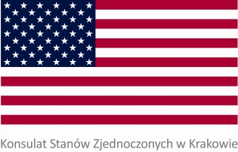

FULBRIGHT DAY

AT POLITECHNIKA KRAKOWSKA

March 26, 2013

Campus , Gallery *GIL*, Room 108

10:00 – 10:15 Introductions. Welcome remarks

Ellen Germain, Consul General, US Consulate in Krakow

Vice-rector for Education and International Affairs, professor Dariusz Bogdał

10:15 – 10:35 Fulbright Scholarships: Opportunity for reaching a new horizon

Małgorzata Krasowska, Executive Director, Fulbright Commission, Warsaw

10:35 – 10:55 American Fulbright Researchers: why study in the U.S.

10:55 – 11:20 American Fulbright Students speak on the offer of the U.S. universities and life on campus.

11:20 – 11:40 Coffee Break

11:50 - 12:10 Graduate Engineering Studies in the US: Choice, Application, Funding, Visas

Maria Brzostek, Educational Advisor, US Consulate, Krakow

12:10 – 12:20 Questions, Wrap-up